**DB LAB ASSIGNMENT**



**Session 2023 - 2027**

**Submitted by:**

Sumaira Hafeez 2023-CS-1

**Supervised by:**

Sir Faraz

**Course:**

DataBase Lab

Department of Computer Science

**University of Engineering and Technology Lahore Pakistan.**

**SELECT QUERY IN PROCEDURE**

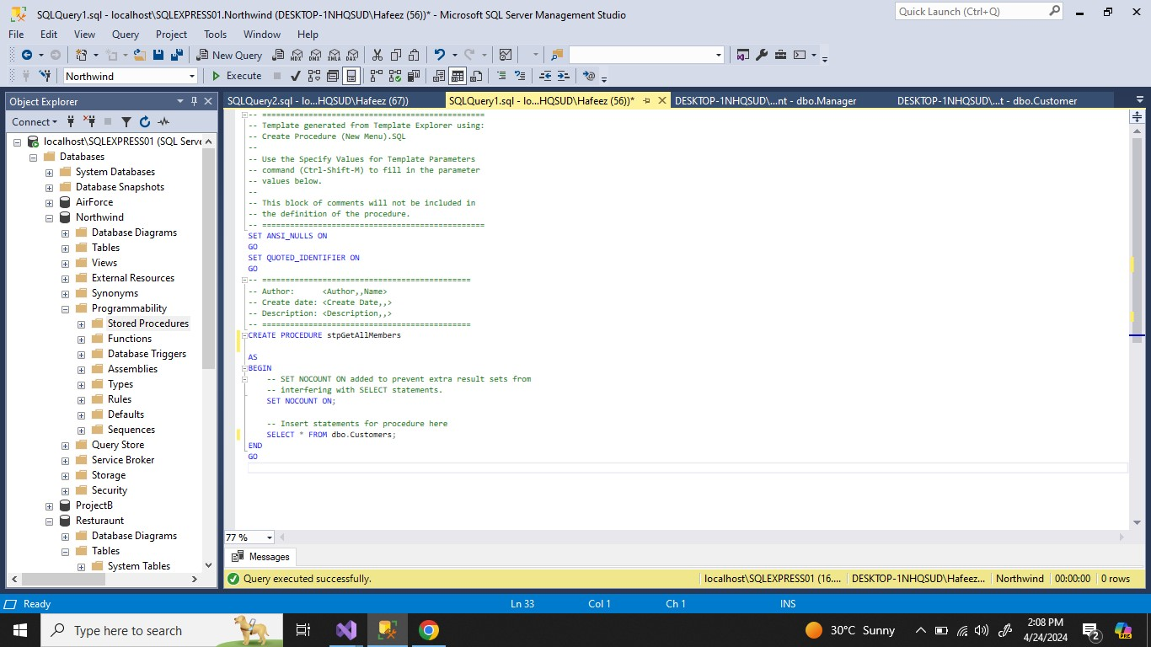

**EXECUTION**

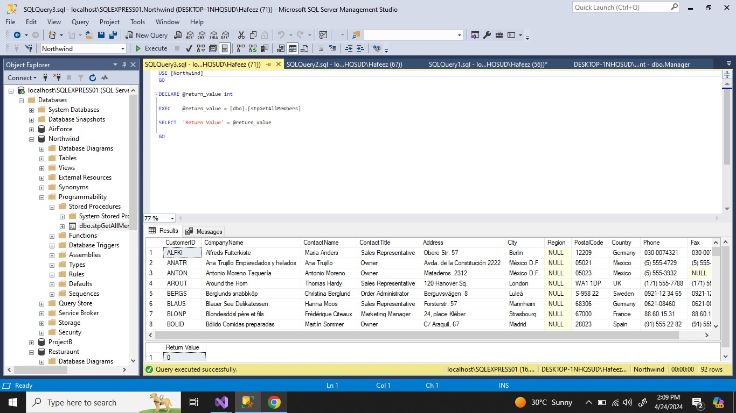

**QUERY EXECUTION**

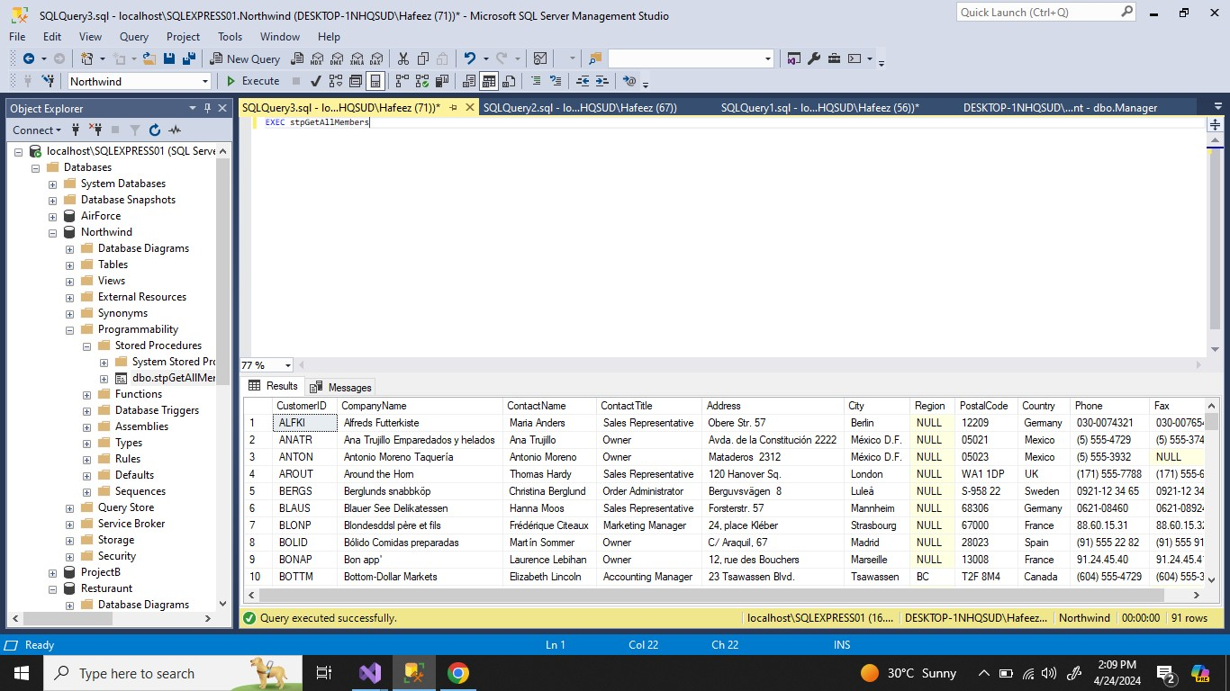

**INSERT QUERY**

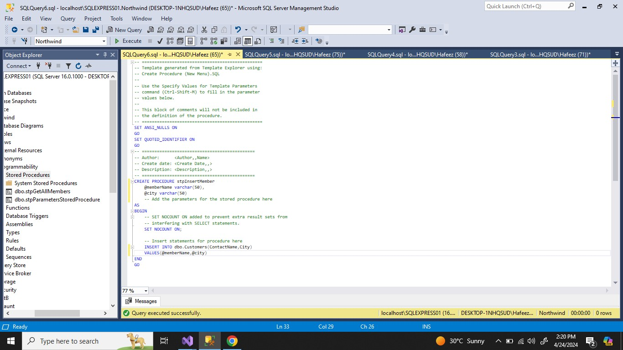

**EXECUTION**

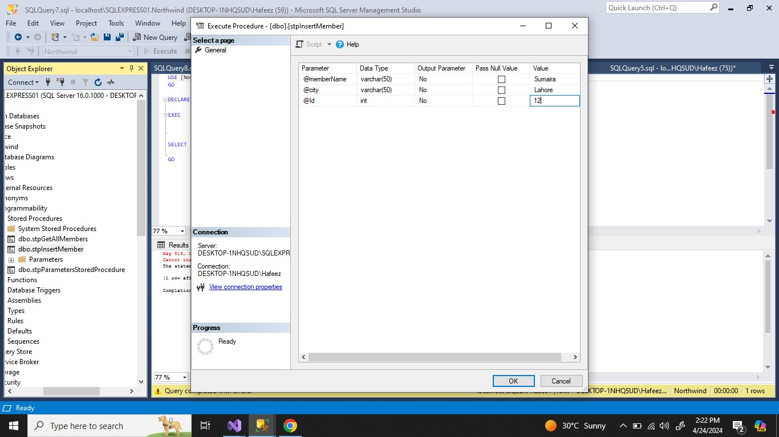

**EXECUTION**

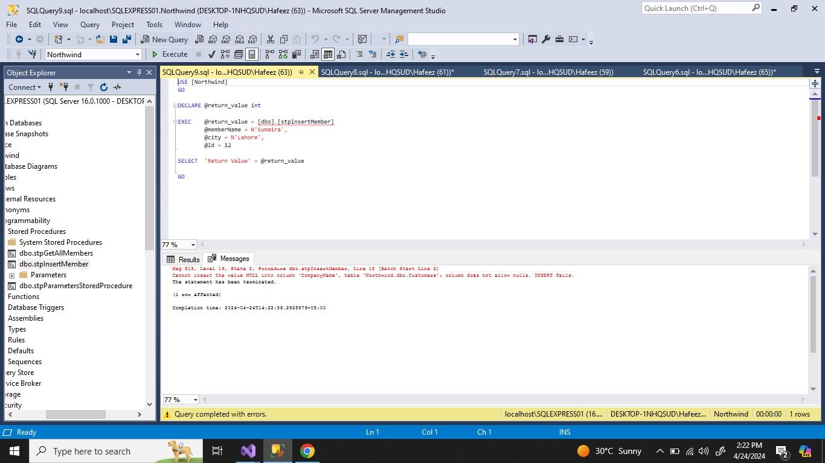

**NULL VALUE EXCEPTION AT CompanyName**

**UPDATE QUERY**

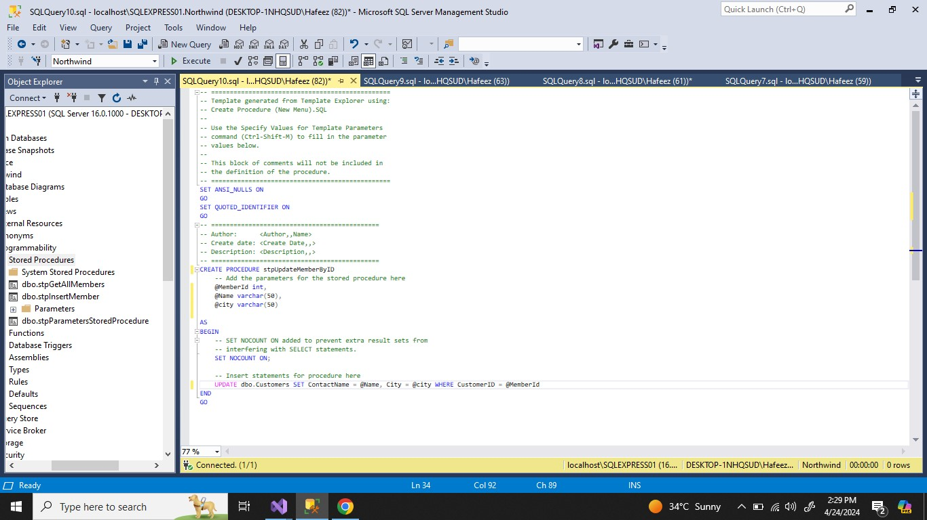

**EXECUTION**

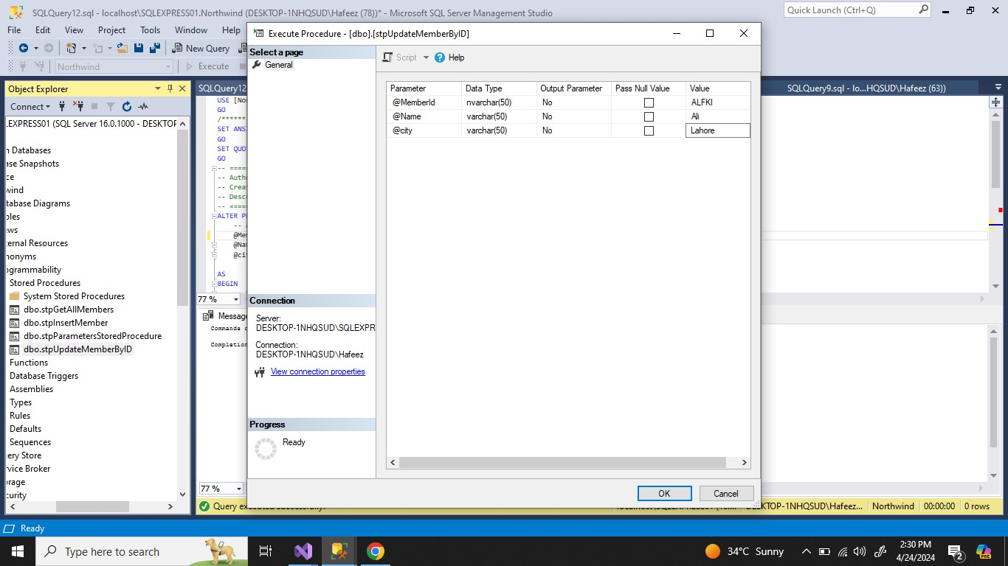

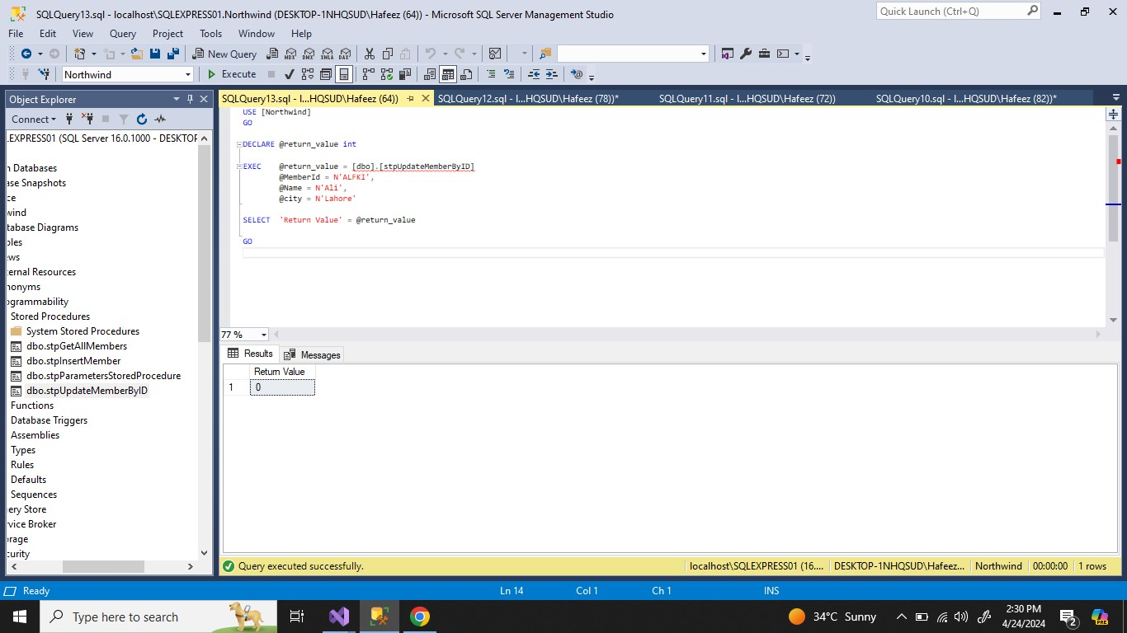

**DELETE QUERY**

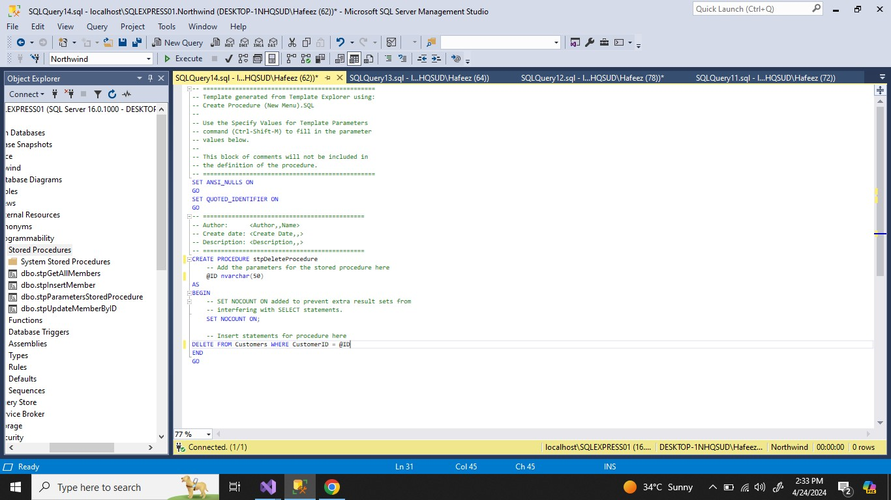

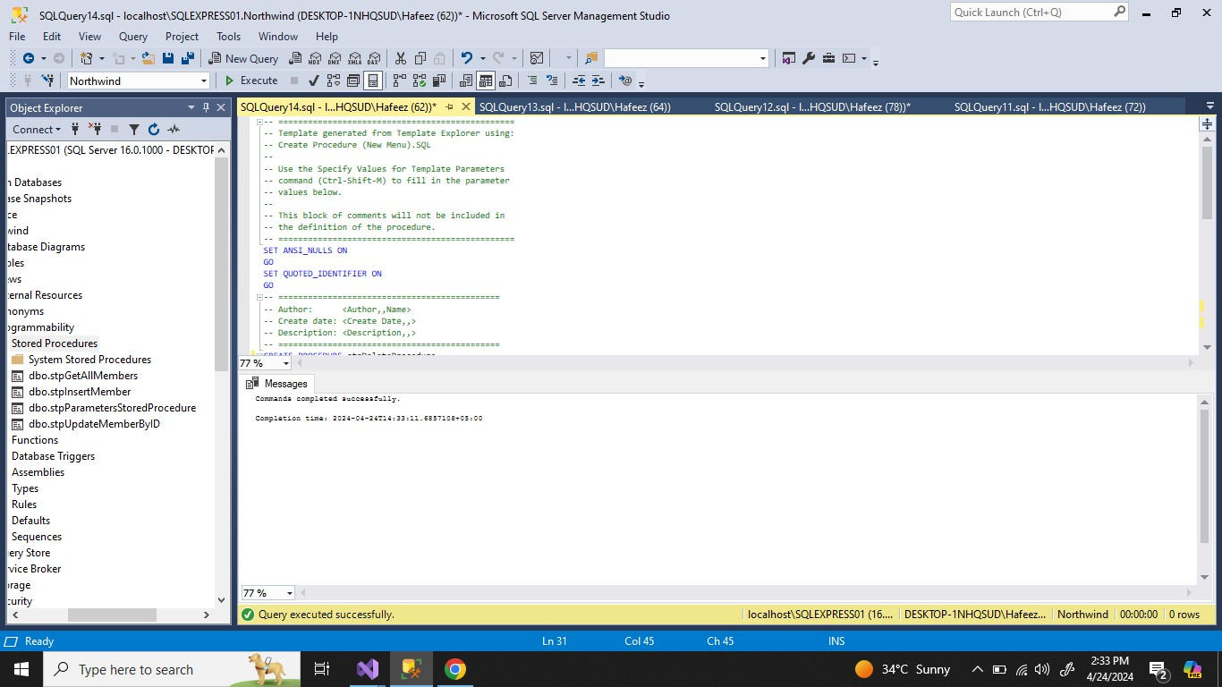

**EXECUTION**

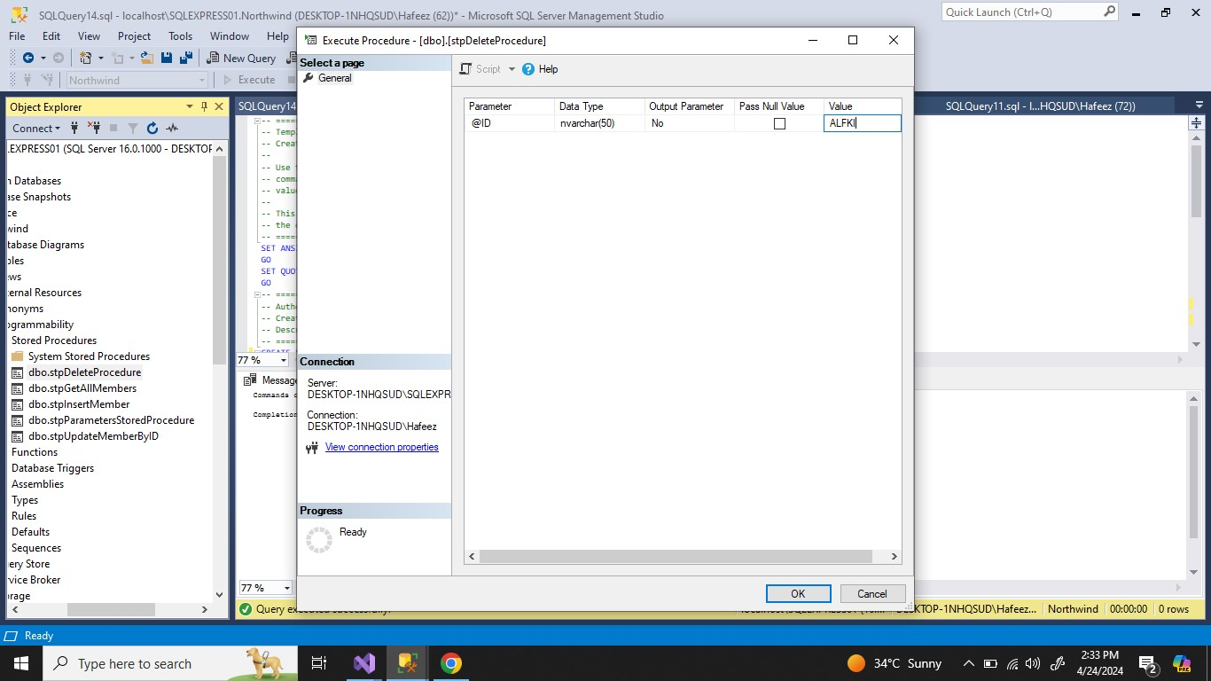

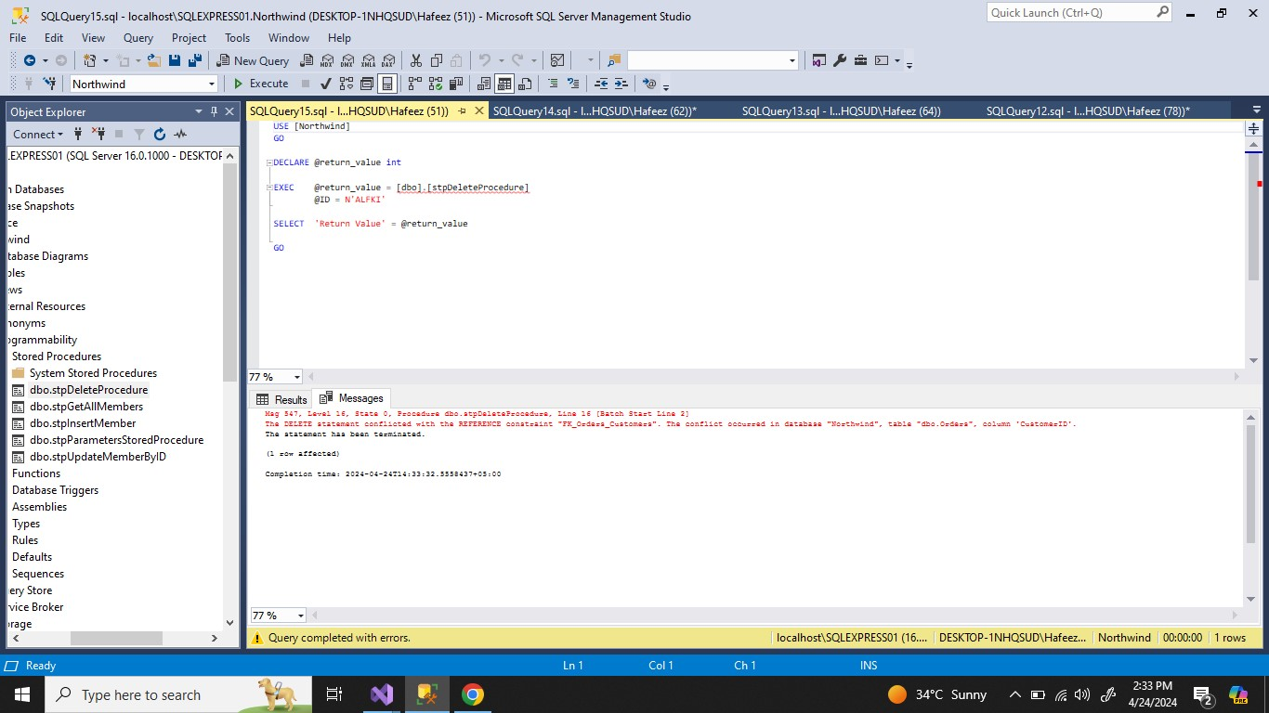

**Unable to delete because the foreign key reference is used in other table**

**MODIFY PROCEDURE**

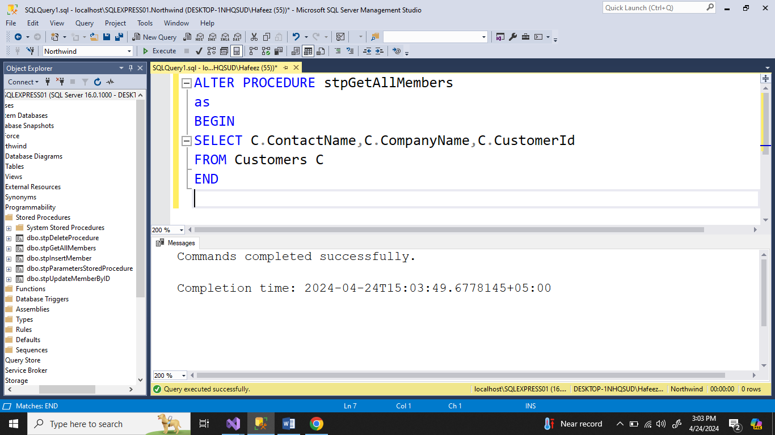

**RENAME PROCEDURE**

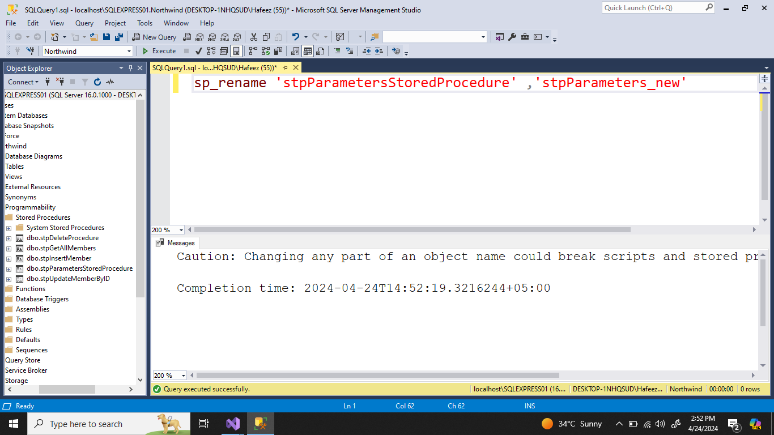

**DROP PROCEDURE**

